Christus Lutheran Church

Christmas Morning
Lessons and Carols

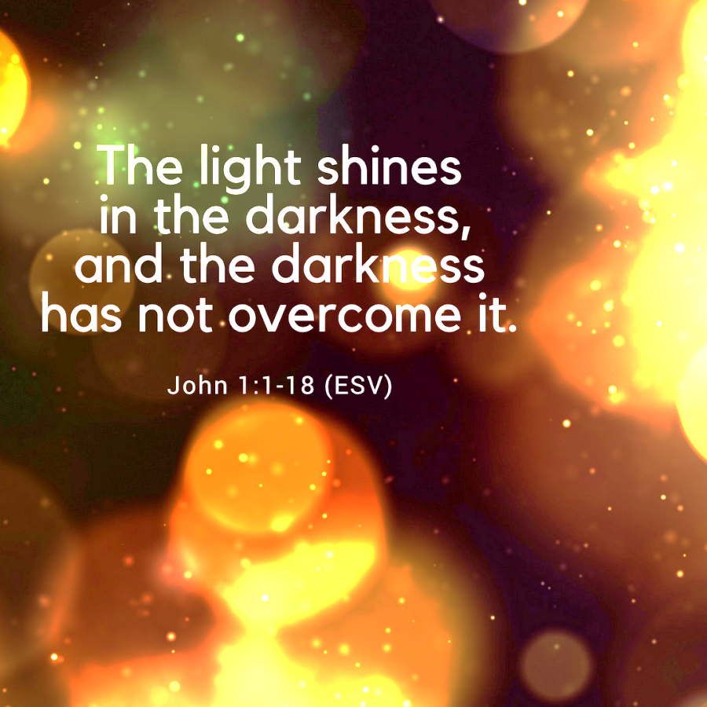

Large Print Complete
10:00am
Dec. 25, 2023

PRELUDE Nancy Netzel

WELCOME

OPENING LITANY
P: The Word was made flesh, and we beheld his glory.
C: Oh, come, let us worship him.

CONFESSION & FORGIVENESS
Kneel as you are able, or be seated
P: Almighty and Everlasting God;
C: in the glory of your light, we see the darkness of our sin. Set us free by the innocent suffering and death of your beloved Son, and breathe your Spirit into us, so that we might walk in the paths of righteousness; through Jesus Christ our Lord. Amen
P: In the mercy of Almighty God, he sent his only begotten Son to suffer and die, so that your sins may be forgiven and you may live. By the command of our Lord Jesus Christ, and by his authority, I declare to you the entire forgiveness of all your sins; in the name of the Father, and of the Son, and of the Holy Spirit.
C: Amen
Stand
OPENING PRAYER
P: Almighty God,
C: you made this holy day shine with the brightness of the true Light. Grant that here on earth we may walk in the light of Jesus’ presence and in the last day wake to the brightness of his glory; through your only Son, Jesus Christ our Lord, who lives and reigns with you and the Holy Spirit, one God, now and forever. Amen.

OPENING SONG: When Christmas Morn Is Dawning
LBW #59
1 When Christmas morn is dawning I wish that I could be
There by the manger cradle God’s Son, newborn, to see.
There by the manger cradle God’s Son, newborn, to see.

2 How kind of you, our Savior, for us to come to earth.
Oh, may we not by sinning despise your lowly birth.
Oh, may we not by sinning despise your lowly birth.

3 We need you, O Lord Jesus, to be our dearest friend.
Your love will guard and guide us
and keep us to life’s end.
Your love will guard and guide us
and keep us to life’s end.
Be Seated

LESSONS AND CAROLS
LESSON ONE: Genesis 3:8-19
⁸ And they heard the sound of the Lord God walking in the garden in the cool of the day, and the man and his wife hid themselves from the presence of the Lord God among the trees of the garden. ⁹ But the Lord God called to the man and said to him, “Where are you?” ¹⁰ And he said, “I heard the sound of you in the garden, and I was afraid, because I was naked, and I hid myself.” ¹¹ He said, “Who told you that you were naked? Have you eaten of the tree of which I commanded you not to eat?” ¹² The man said, “The woman whom you gave to be with me, she gave me fruit of the tree, and I ate.” ¹³ Then the Lord God said to the woman, “What is this that you have done?” The woman said, “The serpent deceived me, and I ate.”

¹⁴ The Lord God said to the serpent,
“Because you have done this,
cursed are you above all livestock
and above all beasts of the field;
on your belly you shall go,
and dust you shall eat
all the days of your life.
¹⁵ I will put enmity between you and the woman,
and between your offspring and her offspring;
he shall bruise your head,
and you shall bruise his heel.”
¹⁶ To the woman he said,
“I will surely multiply your pain in childbearing;
in pain you shall bring forth children.
Your desire shall be contrary to your husband,
but he shall rule over you.”
¹⁷ And to Adam he said,
“Because you have listened to the voice of your wife
and have eaten of the tree
of which I commanded you,
‘You shall not eat of it,’
cursed is the ground because of you;
in pain you shall eat of it all the days of your life;
¹⁸ thorns and thistles it shall bring forth for you;
and you shall eat the plants of the field.
¹⁹ By the sweat of your face
you shall eat bread,
till you return to the ground,
for out of it you were taken;
for you are dust,
and to dust you shall return.”

CAROL: “O Come, O Come Emmanuel”
LBW #34 vs 1, 3, 5
1 Oh, come, oh, come, Emmanuel,
And ransom captive Israel,
That mourns in lonely exile here
Until the Son of God appear.
Refrain: Rejoice! Rejoice!
Emmanuel Shall come to you, O Israel!

3 Oh, come, strong Branch of Jesse, free
Your own from Satan's tyranny;
From depths of hell your people save
And give them vict'ry o'er the grave. Refrain

5 Oh, come, O Key of David, come,
And open wide our heav'nly home;
Make safe the way that leads on high,
And close the path to misery. Refrain

LESSON TWO: Genesis 22:15-18
¹⁵ The Lord God took the man and put him in the garden of Eden to work it and keep it. ¹⁶ And the Lord God commanded the man, saying, “You may surely eat of every tree of the garden, ¹⁷ but of the tree of the knowledge of good and evil you shall not eat, for in the day that you eat of it you shall surely die.”
¹⁸ Then the Lord God said, “It is not good that the man should be alone; I will make him a helper fit for him.”

CAROL: “Angels from the Realms of Glory”
LBW #50 vs 1, 4
1 Angels, from the realms of glory,
Wing your flight o’er all the earth;
Once you sang creation’s story;
Now proclaim Messiah’s birth:

Refrain: Come and worship, come and worship,
worship Christ, the newborn king.
4 All creation, join in praising
God, the Father, Spirit, Son,
Evermore your voices raising
To the eternal Three in One. Refrain

LESSON THREE: Isaiah 9:2, 6
²The people who walked in darkness
have seen a great light;
those who dwelt in a land of deep darkness,
on them has light shone.
⁶ For to us a child is born,
to us a son is given;
and the government shall be upon his shoulder,
and his name shall be called
Wonderful Counselor, Mighty God,
Everlasting Father, Prince of Peace.

CAROL: “O Little Town of Bethlehem”
LBW #41 vs 2, 4
2 For Christ is born of Mary,
and gathered all above,
while mortals sleep, the angels keep
their watch of wond’ring love.
O morning stars together,
proclaim the holy birth,
and praises sing to God the king,
and peace to all on earth!

4 O holy Child of Bethlehem,
descend to us, we pray;
cast out our sin, and enter in,
be born in us today.
We hear the Christmas angels
the great glad tidings tell;
oh, come to us, abide with us,
our Lord Emmanuel!

LESSON FOUR: Isaiah 11:1-3a, 4a, 6
¹ There shall come forth a shoot from the stump of Jesse,
and a branch from his roots shall bear fruit.
² And the Spirit of the Lord shall rest upon him,
the Spirit of wisdom and understanding,
the Spirit of counsel and might,
the Spirit of knowledge and the fear of the Lord.
³ And his delight shall be in the fear of the Lord.
⁴ but with righteousness he shall judge the poor,
and decide with equity for the meek of the earth;
⁶ The wolf shall dwell with the lamb,
and the leopard shall lie down with the young goat,
and the calf and the lion and the fattened calf together;
and a little child shall lead them.

CAROL: “Joy To The World” LBW #39 vs 1, 4
1 Joy to the world, the Lord is come!
Let earth receive her King;
Let ev’ry heart prepare Him room
And heav’n and nature sing, and heav’n and nature sing,
And heav’n, and heav’n and nature sing.

4 He rules the world with truth and grace
And make the nations prove
The glories of his righteousness
And wonders of his love, and wonders of his love,
and wonders, wonders of his love.

LESSON FIVE: Luke 1:26-35, 38
²⁶ In the sixth month the angel Gabriel was sent from God to a city of Galilee named Nazareth, ²⁷ to a virgin betrothed to a man whose name was Joseph, of the house of David. And the virgin's name was Mary. ²⁸ And he came to her and said, “Greetings, O favored one, the Lord is with you!” ²⁹ But she was greatly troubled at the saying, and tried to discern what sort of greeting this might be. ³⁰ And the angel said to her, “Do not be afraid, Mary, for you have found favor with God. ³¹ And behold, you will conceive in your womb and bear a son, and you shall call his name Jesus. ³² He will be great and will be called the Son of the Most High. And the Lord God will give to him the throne of his father David, ³³ and he will reign over the house of Jacob forever, and of his kingdom there will be no end.”
³⁴ And Mary said to the angel, “How will this be, since I am a virgin?”
³⁵ And the angel answered her, “The Holy Spirit will come upon you, and the power of the Most High will overshadow you; therefore the child to be born will be called holy—the Son of God.
³⁸ And Mary said, “Behold, I am the servant of the Lord; let it be to me according to your word.” And the angel departed from her.

CAROL: “What Child Is This?” LBW #40 vs 1, 3
1 What child is this, who, laid to rest,
on Mary’s lap is sleeping?
Whom angels greet with anthems sweet
While shepherds watch are keeping?
This, this is Christ the king,
Whom shepherds guard and angels sing;
Haste, haste to bring him laud,
The babe, the son of Mary!

3 So bring him incense, gold, and myrrh;
Come, peasant, king to own him.
The King of kings salvation brings;
Let loving hearts enthrone him.
Raise, raise the song on high,
The virgin sings her lullaby;
Joy, joy, for Christ is born,
The babe, the son of Mary!

LESSON SIX: Luke 2:1, 3-7
¹ In those days a decree went out from Caesar Augustus that all the world should be registered. ³ And all went to be registered, each to his own town. ⁴ And Joseph also went up from Galilee, from the town of Nazareth, to Judea, to the city of David, which is called Bethlehem, because he was of the house and lineage of David, ⁵ to be registered with Mary, his betrothed, who was with child. ⁶ And while they were there, the time came for her to give birth. ⁷ And she gave birth to her firstborn son and wrapped him in swaddling cloths and laid him in a manger, because there was no place for them in the inn.

CAROL: “Away in a Manger” LBW #67 vs 1, 3
1 Away in a manger, no crib for a bed,
The little Lord Jesus lay down his sweet head;
The stars in the sky looked down where he lay,
The little Lord Jesus asleep on the hay.

3 Be near me, Lord Jesus, I ask thee to stay
Close by me forever, and love me, I pray.
Bless all the dear children in thy tender care,
And fit us for heaven to live with thee there.

LESSON SEVEN: Luke 2:8-16
⁸ And in the same region there were shepherds out in the field, keeping watch over their flock by night. ⁹ And an angel of the Lord appeared to them, and the glory of the Lord shone around them, and they were filled with great fear. ¹⁰ And the angel said to them, “Fear not, for behold, I bring you good news of great joy that will be for all the people. ¹¹ For unto you is born this day in the city of David a Savior, who is Christ the Lord. ¹² And this will be a sign for you: you will find a baby wrapped in swaddling cloths and lying in a manger.” ¹³ And suddenly there was with the angel a multitude of the heavenly host praising God and saying,
¹⁴ “Glory to God in the highest, and on earth peace among those with whom he is pleased!”
¹⁵ When the angels went away from them into heaven, the shepherds said to one another, “Let us go over to Bethlehem and see this thing that has happened, which the Lord has made known to us.” ¹⁶ And they went with haste and found Mary and Joseph, and the baby lying in a manger.

CAROL: “Hark! The Herald Angels Sing”
LBW #60 vs 1, 2
1 Hark! The herald angels sing,
“Glory to the newborn king;
Peace on earth, and mercy mild,
God and sinners reconciled.”
Joyful, all you nations, rise;
Join the triumph of the skies;
With angelic hosts proclaim,
“Christ is born in Bethlehem!”
Hark! The herald angels sing,
“Glory to the newborn king!”

2 Christ, by highest heav’n adored,
Christ, the everlasting Lord,
Late in time behold him come,
Offspring of a virgin’s womb.
Veiled in flesh the Godhead see!
Hail, incarnate deity!
Pleased as man with us to dwell,
Jesus, our Emmanuel!
Hark! The herald angels sing,
“Glory to the newborn king!”

LESSON EIGHT: Matthew 2:1-12
¹ Now after Jesus was born in Bethlehem of Judea in the days of Herod the king, behold, wise men from the east came to Jerusalem, ² saying, “Where is he who has been born king of the Jews? For we saw his star when it rose and have come to worship him.” ³ When Herod the king heard this, he was troubled, and all Jerusalem with him; ⁴ and assembling all the chief priests and scribes of the people, he inquired of them where the Christ was to be born. ⁵ They told him, “In Bethlehem of Judea, for so it is written by the prophet:
⁶ “‘And you, O Bethlehem, in the land of Judah,
are by no means least among the rulers of Judah;
for from you shall come a ruler
who will shepherd my people Israel.’”
⁷ Then Herod summoned the wise men secretly and ascertained from them what time the star had appeared. ⁸ And he sent them to Bethlehem, saying, “Go and search diligently for the child, and when you have found him, bring me word, that I too may come and worship him.” ⁹ After listening to the king, they went on their way. And behold, the star that they had seen when it rose went before them until it came to rest over the place where the child was. ¹⁰ When they saw the star, they rejoiced exceedingly with great joy. ¹¹ And going into the house, they saw the child with Mary his mother, and they fell down and worshiped him. Then, opening their treasures, they offered him gifts, gold and frankincense and myrrh. ¹² And being warned in a dream not to return to Herod, they departed to their own country by another way.

CAROL: “Star of the East”
1 Star of the East, oh Bethlehem’s star,
Guiding us on to heaven afar.
Sorrow and grief are lulled by thy light
Thou hope of each mortal, in death’s lonely night.
Fearless and tranquil we look up to thee,
Knowing thou beam’st through eternity.
Help us to follow where thou still dost guide,
Pilgrims of earth so wide.

2 Star of the East, undimmed by each cloud,
What though the storms of grief gather loud,
Faithful and pure thy rays’ beam to save,
Still bright o’er the cradle and bright o’er the grave.
O star that leads to God above,
whose rays are peace, are joy and love,
watch o’er us still till life hath ceased,
Beam on, bright star, sweet Bethlehem star.

LESSON NINE: John 1:1-14
¹ In the beginning was the Word, and the Word was with God, and the Word was God. ² He was in the beginning with God. ³ All things were made through him, and without him was not any thing made that was made. ⁴ In him was life, and the life was the light of men. ⁵ The light shines in the darkness, and the darkness has not overcome it. ⁶ There was a man sent from God, whose name was John. ⁷ He came as a witness, to bear witness about the light, that all might believe through him. ⁸ He was not the light, but came to bear witness about the light.
⁹ The true light, which gives light to everyone, was coming into the world. ¹⁰ He was in the world, and the world was made through him, yet the world did not know him. ¹¹ He came to his own, and his own people did not receive him. ¹² But to all who did receive him, who believed in his name, he gave the right to become
children of God, ¹³ who were born, not of blood nor of the will of the flesh nor of the will of man, but of God.
¹⁴ And the Word became flesh and dwelt among us, and we have seen his glory, glory as of the only Son from the Father, full of grace and truth.

CAROL: “O Come, All Ye Faithful” LBW #45 vs 1, 2, 4
1 Oh, come, all ye faithful, joyful and triumphant!
Oh, come ye, oh, come ye to Bethlehem;
Come and behold him, born the king of angels:

Refrain: Oh, come, let us adore him;
Oh, come, let us adore him;
Oh, come, let us adore him, Christ the Lord!

2 The highest, most holy, Light of light eternal,
Born of a virgin, a mortal he comes;
Son of the Father now in flesh appearing! Refrain

4 Yea, Lord, we greet thee, born this happy morning;
Jesus, to thee be glory giv’n!
Word of the Father, now in flesh appearing: Refrain

HOMILY
Stand
NICENE CREED
P: Together with the saints of all times and places, we confess our faith, using the words of the Nicene Creed.
We believe in one God, the Father, the Almighty, maker of heaven and earth; of all that is, seen and unseen.
We believe in one Lord, Jesus Christ, the only Son of God, eternally begotten of the Father; God from God, Light from Light, True God from True God; begotten, not made; of one Being with the Father. Through him all things were made. For us and for our salvation, he came down from heaven; by the power of the Holy Spirit, he became incarnate from the virgin Mary, and was made man. For our sake, he was crucified under Pontius Pilate; he suffered death and was buried. On the third day he rose again, in accordance with the Scriptures; he ascended into heaven, and is seated at the right hand of the Father. He will come again in glory to judge the living and the dead, and his kingdom will have no end.
We believe in the Holy Spirit; the Lord, the giver of life, who proceeds from the Father and the Son. With the Father and the Son he is worshiped and glorified. He has spoken through the prophets. We believe in one, holy, catholic and apostolic Church. We acknowledge one baptism for the forgiveness of sins. We look for the resurrection of the dead, and the life of the world to come. Amen
Be Seated
OFFERING

Stand
OFFERTORY PRAYER
P: Let us pray. Almighty and Eternal God,
C: in this season of giving, remind us that your giving precedes and empowers all giving. Make us grateful for your gifts, and make us generous and joyful givers. In Jesus’ name. Amen

THE LORD’S SUPPER
WORDS OF INSTITUTION
LORD’S PRAYER
Be Seated
DISTRIBUTION
Stand
POST-COMMUNION BLESSING

CLOSING HYMN: Good Christian Friends, Rejoice!
LBW #55
1 Good Christian friends, rejoice
With heart and soul and voice;
Give ye heed to what we say:
Jesus Christ is born today;
Ox and ass before him bow,
And he is in the manger now.
Christ is born today! Christ is born today!

2 Good Christian friends, rejoice
With heart and soul and voice;
Now ye hear of endless bliss:
Jesus Christ was born for this!
He has opened heaven’s door,
And we are blest forevermore.
Christ was born for this! Christ was born for this!

3 Good Christian friends, rejoice
With heart and soul and voice;
Now ye need not fear the grave;
Jesus Christ was born to save!
Calls you one and calls you all
To gain his everlasting hall.
Christ was born to save! Christ was born to save!

DISMISSAL
P: Christ the Lord is born for you!
C: Live in me now and always, O Lord!

POSTLUDE Nancy Netzel

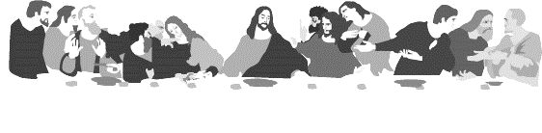
HOLY COMMUNION
All the baptized who believe in the true presence of Christ
in these elements, the bread and wine,
and who know their need of forgiveness,
are welcome to receive the Lord’s Supper.
(1 Cor. 11:23-25; Matt.26:26-28; Mark 14:22-24; Luke 22:19, 20)

Both wine (red) and grape juice (white) are available.
Gluten-free wafers are available – please ask your server for the gluten free wafer if you so choose.
Children who have not received instruction, and those who do not believe in the true presence of Christ in the Supper, may come forward with arms crossed over their hearts to receive a blessing.

Our mission is to invite people of all nations
into fellowship with Jesus Christ,
and to make them His disciples
through preaching and teaching Christ crucified, risen
and coming again as the only hope of eternal salvation.

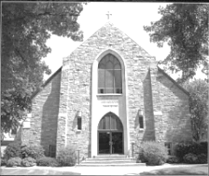
Christus Lutheran Church
120 N. Main St. Clintonville, WI 54929
(715) 823-6521 ● christus@charter.net ●
www.christusclintonville.org
Pastors: Brian Crocker & Shelly Klemp

